21st Century Idolatry
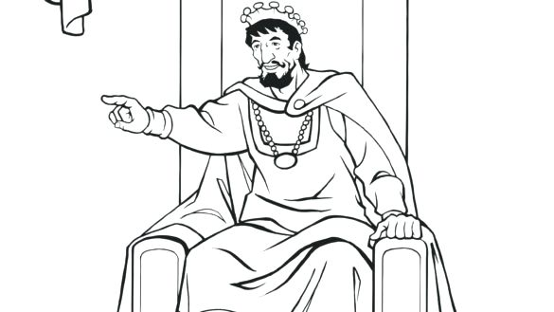
Part 2- The god of entertainment
King Solomon- Writer of Ecclesiastes
Ecclesiastes 2- I said in my heart, “Come now, I will test you with pleasure; enjoy yourself.” But behold, this also was vanity. ² I said of laughter, “It is mad,” and of pleasure, “What use is it?” ³ I searched with my heart how to cheer my body with wine—my heart still guiding me with wisdom—and how to lay hold on folly, till I might see what was good for the children of man to do under heaven during the few days of their life. ⁴ I made great works. I built houses and planted vineyards for myself. ⁵ I made myself gardens and parks, and planted in them all kinds of fruit trees. ⁶ I made myself pools from which to water the forest of growing trees. ⁷ I bought male and female slaves, and had slaves who were born in my house. I had also great possessions of herds and flocks, more than any who had been before me in Jerusalem. ⁸ I also gathered for myself silver and gold and the treasure of kings and provinces. I got singers, both men and women, and many concubines, the delight of the sons of man.
⁹ So I became great and surpassed all who were before me in Jerusalem. Also my wisdom remained with me. ¹⁰ And whatever my eyes desired I did not keep from them. I kept my heart from no pleasure.
¹¹ Yet when I surveyed all that my hands had done
and what I had toiled to achieve,
everything was meaningless, a chasing after the wind;
nothing was gained under the sun.

Solomon had it all-
- Great power. An army and navy controlling the trade routes between Egypt and Asia Minor.
- Great wealth. He had so much gold, he made military shields out of it.
- Pleasure- 700 wives- 300 concubines… it did not satisfy.
- Every form of entertainment- and he was bored, calling all his pursuits a “chasing after the wind.”
- He was an accomplished builder, constructing the Great Temple in Jerusalem
- He was recognized through the known world for wisdom
Yet after a life looking for fulfillment, Solomon wrote this-
Ecclesiastes 3:11 ¹¹ He has made everything beautiful in its time. He has also set eternity in the human heart; yet no one can fathom what God has done from beginning to end.
Ecclesiastes 12:13, “Now all has been heard; here is the conclusion of the matter: Fear God and keep his commandments, for this is the whole duty of man.”
The Church that the NFL Built (and the MLB, and the NCAA, and the NBA, etc.)
From Kyle Idleman, God’s at War, 2014, Zondervan- “(Entertainment’s “temples”) are the great stadiums that are sacred ground to many. Its priests are in the zebra stripes. Its gods wear their names on the back of their jerseys. Its liturgy is fan chants, and its sacrifices are the vast amounts of money that fans pay for tickets and team gear.” P.103
“Never in the history of humanity has there been so much entertainment and so little satisfaction.” P.109
- Internet
- iPhones/ iPods
- Satellite TV
- Cable/ unlimited channels
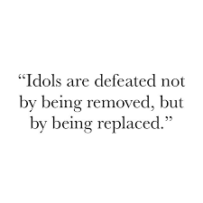
- Social media, etc.
Do we need to turn off the power?
True or false?
The Lord God has often lost out when competing with the gods of entertainment for our time and attention.
Our own false gods tend to be invisible to us. I can probably see yours, but I’ll miss detecting my own.

Kyle Idleman, p.110, “There is a place in life for relaxation through various forms of entertainment, including sports, television, movies, music, and games. But the question is, Do we seek to fill the spiritual vacuum inside us with empty entertainment, or is it the empty entertainment that is creating the vacuum? There is plenty of evidence that our increasing reliance on the flash and glamour of entertainment is blinding us to the quieter and truer pleasures.”
St. Augustine wrote this in a prayer fifteen centuries ago-
“Our hearts are restless until they find rest in Thee.”
Jesus said-
John 10:10- I came that you may have life, and have it to the full.

